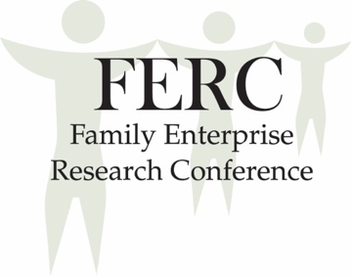

Asheville, North Carolina, U.S.A.
June 8 – 10, 2017
https://fbf.unca.edu/ferc-2017
Call for Papers

The Family Enterprise Research Conference (FERC) is dedicated to developing a community of scholars interested in conducting research into understanding family firms and creating usable knowledge in this field.

Family enterprise research as a discipline was created from connections between practice and scholarship. Likewise, the body of knowledge in the field continues to grow as applications are forged with other academic disciplines and as gaps in the literature are addressed.

Bridging the Gap is the FERC 2017 theme. The theme invites exploration in multiple areas in research:
- Bridging the Gap between generations in a family business;
- Bridging the Gap between research and practice;
- Bridging the Gap across academic disciplines;
- Bridging the Gap in knowledge in the field.
We extend an invitation for FERC 2017 participants to examine Bridging the Gap in the areas that will have impact on the success of family enterprises. We also invite submissions of other research related to family enterprise.

Submission Guidelines
The format for the submissions should be:
- extended abstracts of no more than 5-pages (inclusive of references and tables);
- Microsoft Word Document (.doc or .docx);
- Double-spaced, one-inch margins, 12-point Times Roman font;
- APA 6th edition style for references; and
- Submitted in English or Spanish
The abstract should address the following questions:
- What is the purpose of this project?
- What is the gap in the literature that this project is hoping to address?
- Why is addressing this gap important?
- How does the project address the gap in the literature?
- What are the implications of this project for research and for practice?
- What is the methodology used in this research project?
- What are some of the results?

Manuscripts should be submitted online between December 1, 2016 and February 4, 2017 by following the link on the FERC 2017 website at https://fbf.unca.edu/ferc-2017. Questions regarding academic submissions should be directed to Professor Dianne Welsh, Academic Chair, at dhwelsh@uncg.edu, 336-256-8507.

Decision Process

- All submissions will go through double-blind review.
- Decisions will be guided by reviewers’ ratings and comments.
- Reviewer comments will be shared with authors.
- The decision of the Academic Chair is final.
- Decision letters will be sent via e-mail by March 17, 2017.
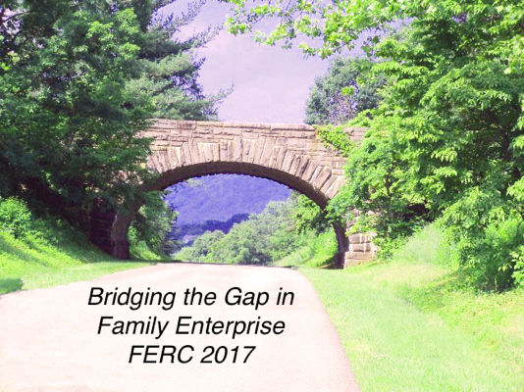
Conference Highlights

Awards
- Best Poster Awards sponsored by MCS Family Wealth Advisors
- Best Poster Awards relating to the topic of Bridging the Gap sponsored by the UNC Asheville Family Business Forum and The Biltmore Company
- FERC Lifetime Influence and Impact Award
- Best Spanish Poster Award sponsored by
Familias Empresarias Management Consulting

Career Academy
The Career Academy Program is designed to address dilemmas and questions at all levels of an academic’s life. To apply, send a C.V. and an e-mail indicating interest to Franz Kellermanns, Kellermanns@uncc.edu. Subject line of e-mail should read FERC Career Academy. Applications should be submitted between December 1, 2016, and February 4, 2017. Participants will be notified of acceptance by March 17, 2017. Additional program information can be found the FERC 2017 website at https://fbf.unca.edu/ferc-2017.

Related Journal and Special Issues
See the FERC 2017 website for updates and information on special issues.

Conference Activities and Events
- Keynote address by Frank Hoy, Paul R. Beswick Professor of Innovation & Entrepreneurship, Worcester Polytechnic Institute
- STEP Meeting
- Panel Discussion of North Carolina family businesses. Moderated by Steve Miller, Ph.D., Family Enterprise Center, UNC Kenan-Flagler Business School
- Beer tastings and family history from local breweries
- Session with journal and special edition editors
- Vanderbilt family history and future of Biltmore Estate from 4th and 5th Generations
- Tour of the Biltmore Estate, the largest private home in the United States
- Awards ceremony on 100-year-old family farm followed by an old-fashioned square dance
- Accommodations in downtown Asheville, with easy walking to galleries, unique shops, and delicious food

Conference Organizing Team
Dianne Welsh, Academic Chair, UNC Greensboro, dhwelsh@uncg.edu
Franz Kellermanns, Career Academy, UNC Charlotte & WHU, Kellermanns@uncc.edu
Cindy Clarke, Conference Director/Logistics, UNC Asheville, cclarke@unca.edu
Donna Boone Parsons, Program Chair, Mars Hill University, dparsons@mhu.edu

Registration
Registration for FERC 2017 will be available online at https://fbf.unca.edu/ferc-2017.
Early bird registration begins December 1, 2016 and ends April 30, 2017.

Additional information about Asheville, North Carolina, travel arrangements and FERC 2017 may be found online at https://fbf.unca.edu/ferc-2017.
August, 2016

